**CS 457 Project #2 – Noisy Elliptical Dots**

**By**: Rick Menzel  **Email**: [menzelr@oregonstate.edu](mailto:menzelr@oregonstate.edu)

**Screenshot(s)**:

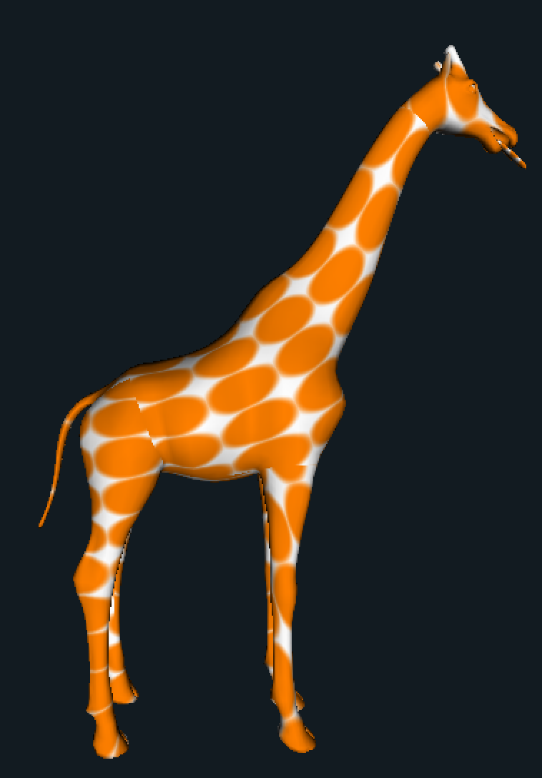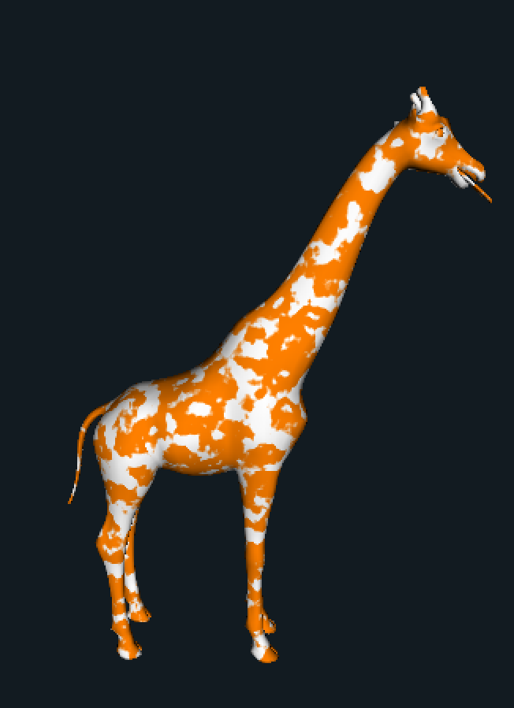

Fig 1a. Giraffe with and without Noise

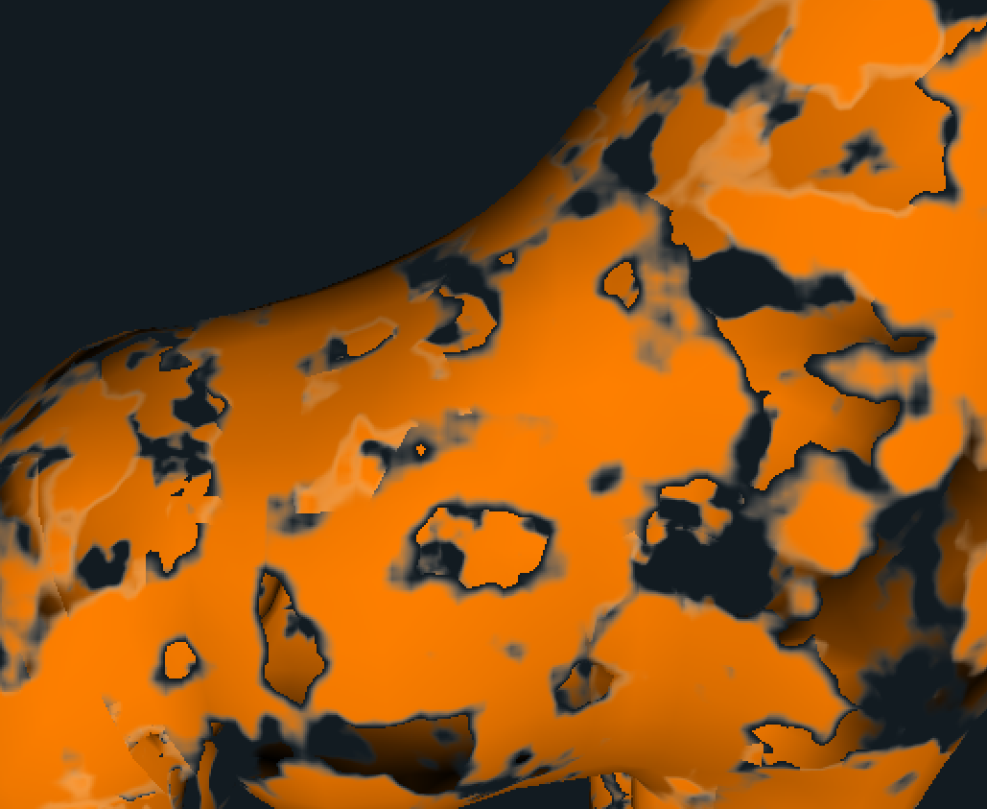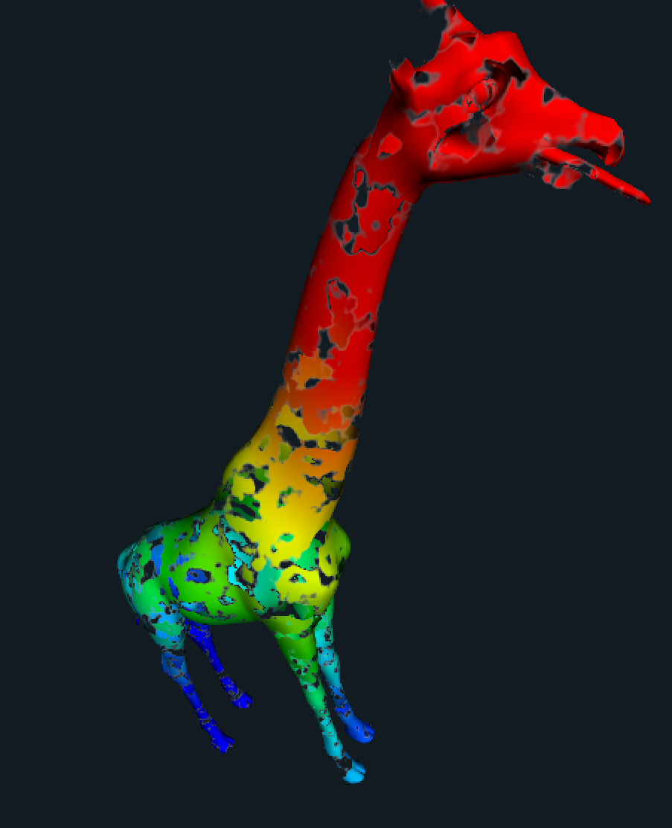

Fig 2. Giraffe with Alpha/Discard Fig 3. Chromadepth Giraffe

**Link**:

<https://media.oregonstate.edu/media/t/0_8kkneigs>